**R Code for Examples in the book**

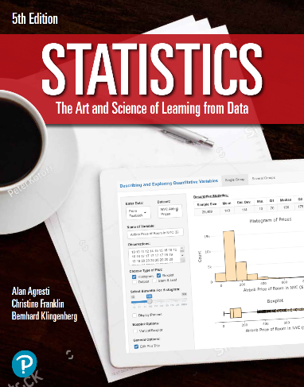

***“Statistics: The Art and Science of Learning from Data”***

**by Agresti, Franklin and Klingenberg, 5th edition**

**Chapter 3**

**Example 8: Internet and Facebook Use – Correlation Coefficient**

## Reading in the data:

internet <- read.csv(file='https://raw.githubusercontent.com/artofstat/data/master/Chapter3/InternetUse.csv')  
attach(internet) # so we can refer to variable names

## To find the correlation coefficient between internet use and facebook use

cor(Internet.Penetration, Facebook.Penetration)

## [1] 0.6140508